Project Report

Football Club Management

Group-19

Kazi Ehsanul Mubin

ID-18101391

Umma Tania Arafin

ID- 18201203

CSE471 Lab Project

Section 02

Introduction

In the Football Club Management System, we'll try to manage a football team using a software System. A football team may need many personnel to manage. So, it is very important to optimize the available resources to get the maximum output. So, we can use a system that helps the teams to manage their players and staff. This system will have a database with information and statistics about every player of the club. So, for a match, staff and coaches can easily review the data to find optimal players for a role. Moreover, team principles can also manage the wages of players and other staff. In the modern era of Commercialized football, we can see the importance of a software like football club management system. It helps to run a football club more efficiently and helps to provide the best performance on and off the pitch.

Motivation

Football is the most influential sport in the world. It has a large and dedicated fan base around many corners of the world. As a football fan ourselves, we always wanted to make a project related to football. In the commercialized era of football, a software system is very much needed. Many football clubs now have dedicated software to observe and analyze matches and players. It helps them to come up with better strategies. In our project we mainly focused on how a club should run, and how a system can provide advantages to a team to easily manage the sporting and non-sporting part of the sports. The interaction and responsibility of players, coaches and staff can be distributed across the software system to maximize the positivity of the team and its management.

System Request

Project Sponsor-

The project Sponsor can be the football federation of a country or a nation. Also, a holding company can be the Project sponsor where the company sells the system as a subscription method to football clubs.

Business Needs-

In the age of commercialized football, the need for a proper club management system is very significant. A football club is often run by some staff. They manage the club and core staff. They manage all the staff and players. But by using a software system. We can manage a club more efficiently and help to improve the performance on and off the pitch.

Business Requirements-

* A centralized database of the players and staff.
* A proper login system and different UI for players, club officials and journalists.
* A proper database for tracking players performance in recent games or whole careers.
* A sorting algorithm to find the optimal player for a specific position.
* A record of the salary and wages for players and club officials.
* A method to communicate between players and staff.

Business Value-

On average a football club in EPL spends 60 million dollars per year. The average spending on management on running the club can be 20 million dollars per year. In an era where every penny is important for this game. We can use this system to reduce the cost.

* By selling as a subscription-based system, the system can profit over a long period of time.
* Expecting sells 100,000$ in the first year, if implemented correctly.
* Expecting sales to a lot of teams as there is no competition for this kind of service. Potential buyers can reach 30-50 clubs.

Special Issue or Constraints-

* Many of the successful clubs already have an on house-built management system. So, this system must provide better services than those systems to attract bigger clubs.
* It should also have a marketing team to promote the product to the clubs.
* First build of the project should not take longer, and it should be distributed to smaller clubs for testing.
* The project should not expect huge sales in the first few years. As this project will take some time to adopt in the modern philosophy of clubs.

Requirement Analysis

# System Features

*In the Football Management System, we should have many functional and non-functional requirements. The major services for the system would be to create a database that stores information about the club, staff and players including stats and performance-based data. Moreover, the system should have a communication platform between players and staff. System should have a dashboard that shows selected players for the next match starting 11 or training time and schedule.*

## Documentation and Representation of data.

*Stores players data and stats and represents data as requested.*

1.1.1 Description and Priority

*The system should document all kinds of player data like name age, height, weight and also performance-based data like goal scored, assist provided, key passes provided and duel won. The system also should calculate basic arithmetic. For example, the system can calculate which player has good passing accuracy by calculating their pass.*

1.1.2 Stimulus/Response Sequences

*Based on the data the system will sort players based on the information provided. For example, if a coach wants a player that has good passing ability, the system should provide the players with great passing and key passing accuracy.*

1.1.3 Functional Requirements

REQ-1: System should be able to store data and statistics about players and staff.

REQ-2: System should represent data if given a constraint.

REQ-3: System should be able to calculate arithmetic like find rate or average and percentages.

REQ-4: System should also calculate the wages and bonuses of players and staff.

REQ-5: System should be able to represent data dynamically when asked.

1.1.4 Non-Functional Requirements

REQ-1: System should provide reliable data that can help staff to find optimal players.

## Communication Platform for players and staff.

*Players and staff should be able to communicate with each other in this system. This system should have a chatting mechanism.*

1.2.1 Description and Priority

*A proper chatting system should be implemented to the system, that allows players, coaches and staff to communicate between each other. There should be a channel for everyone and also a personal communication system.*

1.2.2 Stimulus/Response Sequences

*Platform should have proper ways to communicate, like the use of jpeg and pdf files should be implemented. Having a communication platform can also help players to be in constant communication. System should also have the ability where players can joke or post memes. This will help the player's morale to grow.*

1.2.3 Functional Requirements

REQ-1: A Proper chatting system should be present.

REQ-2: Both personal and group chat should be available for players and staff.

REQ-3: Users should be able to post jpeg, Mp3/mp4 and pdf formatted files.

1.2.4 Non-Functional Requirements

REQ-1: Chat systems should be efficient and fast.

# Other Nonfunctional Requirements

## Performance Requirements

*Performance is a very important constraint for the system. The system should be able to perform properly under various circumstances. As the system database will contain a lot of information, when asked the system should be able to output the data properly.*

## Safety Requirements

*As the database contains a lot of information about players and staff, the system should be secured from any form of hack or attacks. System also has a proper backup program in case of system failure.*

*preferences for various attributes, such as ease of use over ease of learning.*

## Business Rules

*The business potential for the system is quite spectacular. But if implemented correctly the system will prosper. So, we need planned business rules for the system.*

Use Case Diagram

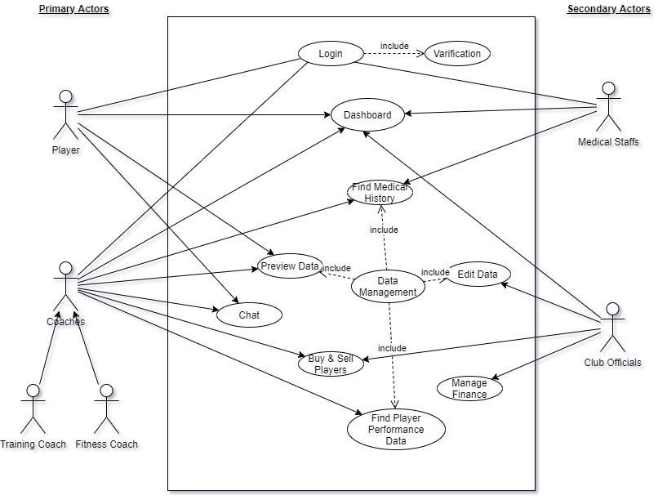

In this use case diagram, we have two primary actors- Players and Coaches. Coaches have two combination Training Coach and Fitness Coach. Medical staff and Club officials act as secondary actors. Their tasks and job are reactionary. Many tasks are distributed among the actors. Tasks like Chat can only be accessed by players or coaches. And other tasks like Dashboard can be accessed by all actors. Club officials can edit data and manage finances which others cannot do. Player buying and selling can only be done by Coaches or Club officials. Like in real life, different club members have different roles in a football club management.

Class Diagram

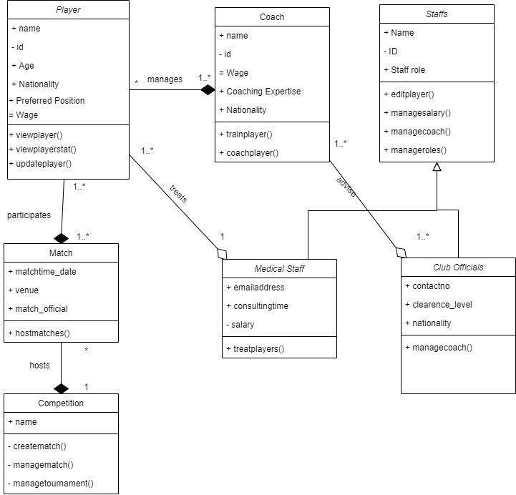

In this class diagram we have many classes. Players, Coach Match, Competition have their own classes. Furthermore, Staff class has two subclasses- Medical Staff or Club official. These classes also have relevant attributes and methods. Classes like players have different kinds of methods than Staff class as they are different in functioning. Moreover, relationship among all the classes has also been visualized here. This diagram reflects how class functions in a football club management system.

Sequence Diagram

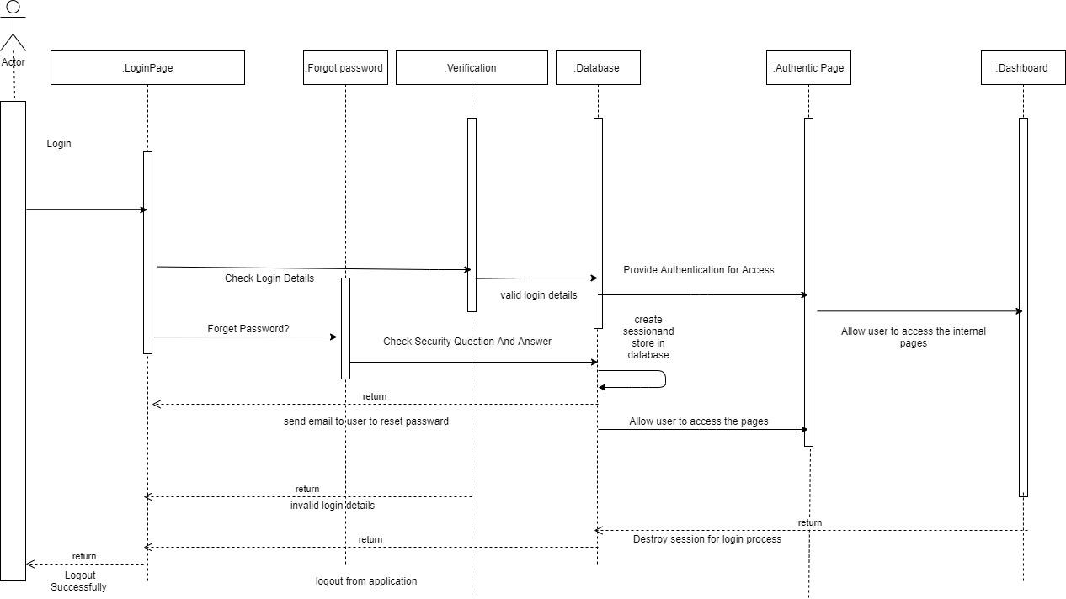

[Write Sequence]

Activity Diagram-1

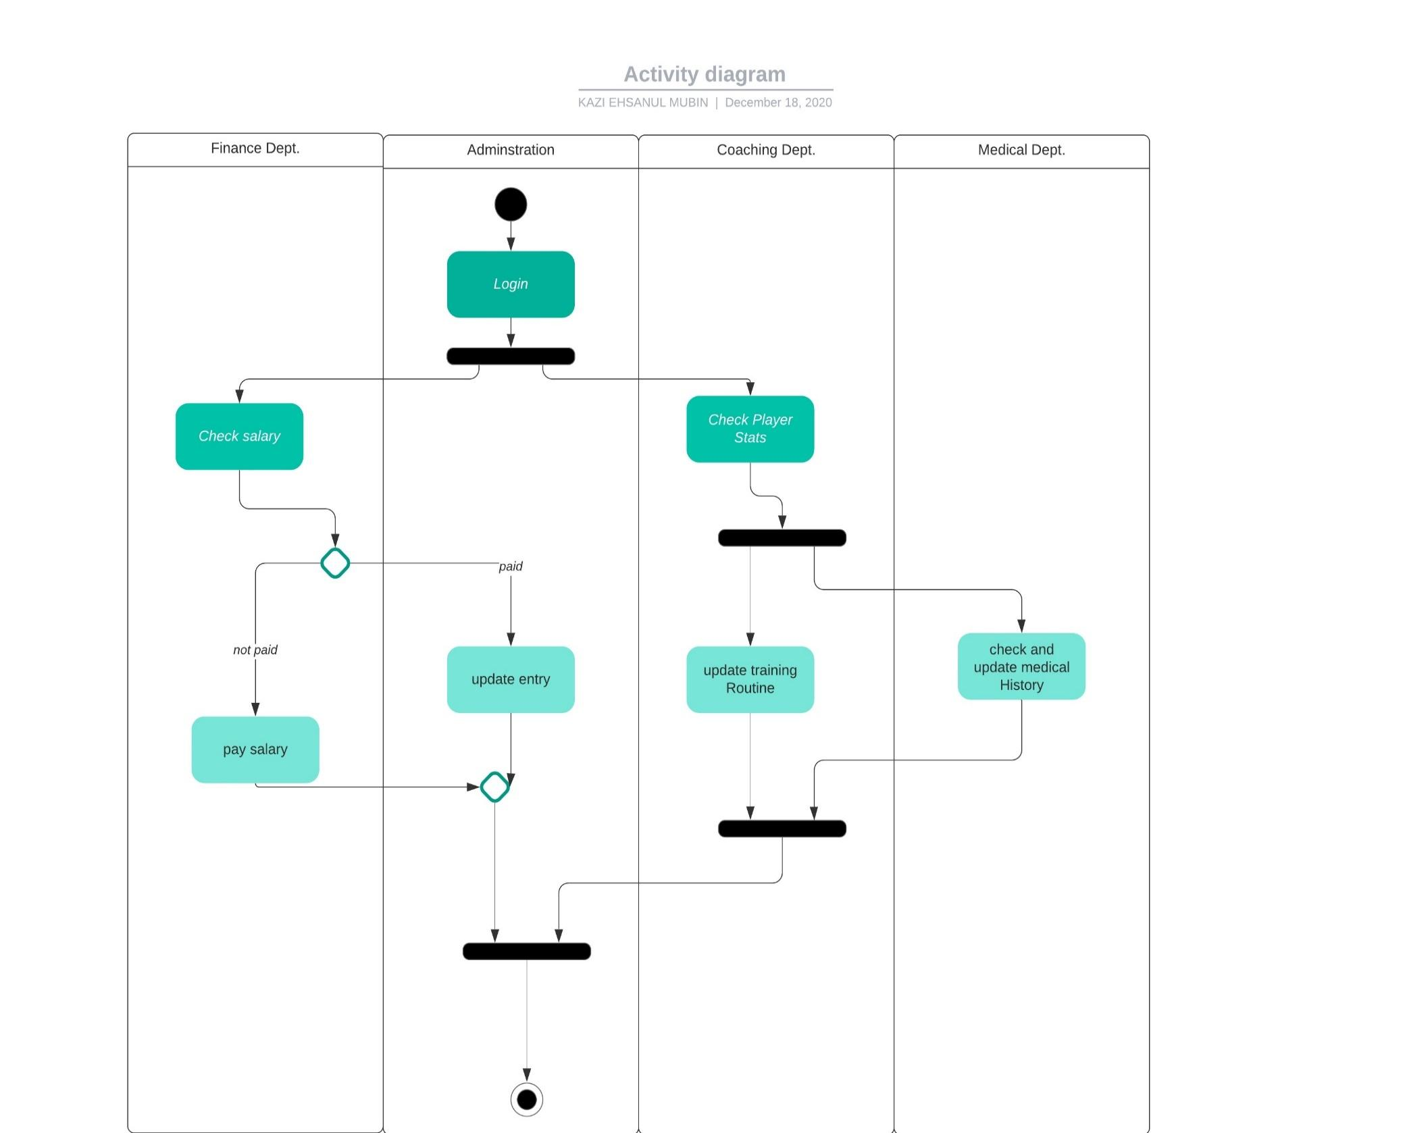

This activity diagram is represented from a club official or medical staff’s point of view. Here tasks are divided into 4 departments. Finance department only concerns financial dealings like the salary of the players. Medical department can check player fitness and if found unfit they can rest players for a limited amount of time.

Activity Diagram-2

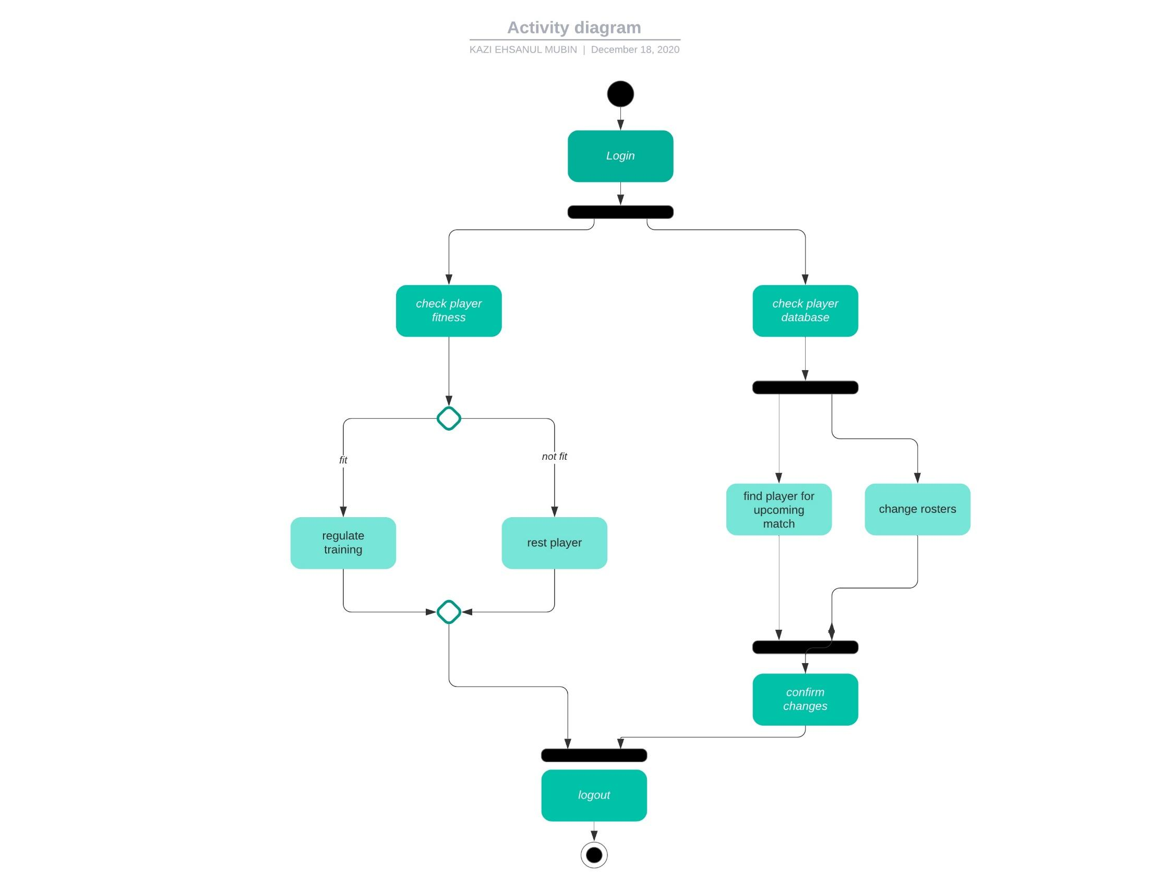

This activity diagram is from the coaches' point of view. Here coaches can check player fitness and change training routine dynamically. Moreover, coaches can also check the player database to find players suitable for playing in a specific role. In this way, they can change the roster or strategy of the team for upcoming matches. Also, both of activity diagram starts with login and logout function

ER Diagram

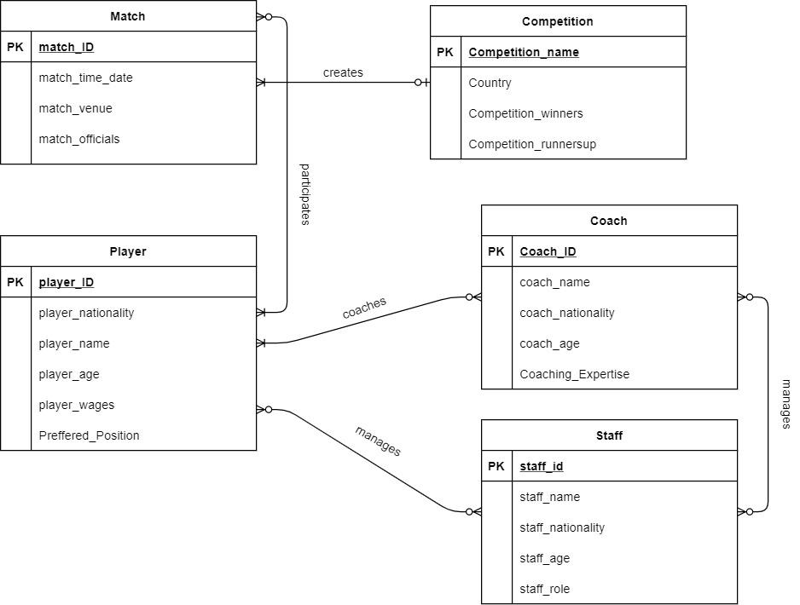

The ER diagram in this project is an adaptation of the class diagram. It has a similar entity like class of this system. Coach, staff, player all the major players and users of the system are considered as different identities in this ER diagram. They also have attributes similar to class diagram. In addition, classes like players can have a lot of attributes like- match played, goal scores, assists, clean sheets, match rating. For time and space conjunction we couldn’t add all the attributes that a player can have. These attributes can be used to find optimal player for a specific goal in mind that was discussed in Activity diagram-2

Windows Navigation Diagram

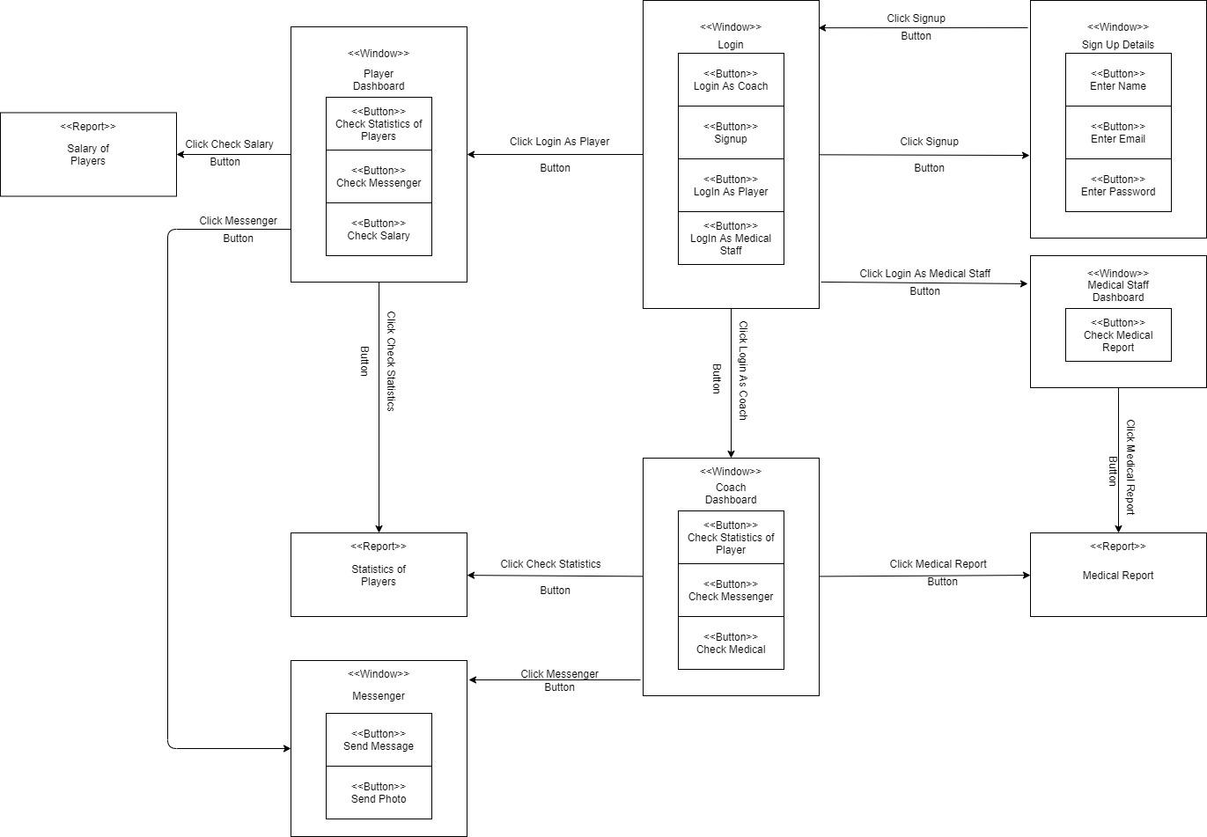

Windows Navigation Diagram mainly focuses on the function of interface in this system. Here we can see that our system basically has 3 kinds of functions from different perspectives. Players, coaches and staff all have different views of the window when login. Moreover, they have different functions compared to others. Like player UI and manager UI both has the option to check or use messenger, which staff UI does not have. On the other hand, staff can view finance reports of players and coaches which players and coaches cannot enter.

Data Flow Diagram

Conclusion

A Football Club managing software would be revolutionary for the sports. Many sports today use some kind of software for their operations. So, there’s a good commercial demand for a good software system. By implementing these types of architecture, we can create sustainable, successful and a complete system for football club management.